Sea scallop drag selectivity study – Northumberland Strait – February 2019
Monique Niles
SMALL <88.9MM
Rational

As a primary conservation objective, the scallop drag design should help avoid harvesting small scallops. There is no minimum size for sea scallops landed in the Gulf fishery at the present time. Also, a common practice of blending the catch allows for small scallops to be shucked together with larger ones while still making the meat count regulation limit. However, size is, to a certain extent, dictated by the drag ring size which is 3¼” (82.6 mm) by conditions of licence.

Theoretically, the meat weight of a 3½” scallop is about 25% heavier than that of 3¼” scallop, according to the shell height to meat weight relationship. The hypothesis is that an increase in ring size from 3¼” to 3½” would result in selecting larger scallops and leaving more small scallops on the bottom, while not affecting catch due to the increased meat yield of larger scallops. Delaying the capture of smaller scallops also increases the reproductive potential in two ways, by increasing the number of sexually mature scallops on the bottom and that these scallops are more fecund (i.e. egg production increases exponentially with size; MacDonald and Thompson, 1985; Langton et al., 1987 ) (Yochum and DuPaul, 2008).

Two studies conducted in the Northumberland Strait showed that gear configuration can influence the size of the scallops retained by the drag (Parsons and Davidson, 2004, M.Mallet, 2000, unpublished data). The use of all steel washers to link rings in the scallop drag caught fewer small scallops than other configurations (1995 study by Parsons and Davidson, 2004). Following a gear selectivity study in 2000 that compared ring sizes (M.Mallet, unpublished data), scallop harvesters increased their ring size from 76 mm to 82.6 mm. At that time, the results indicated that a further increase to 89 mm would significantly impact the catch. Today, more than 15 years later, the size distribution may have shifted enough to warrant such an increase in ring size.
The SFA 22 advisory committee set up a working group to discuss the specific question of scallop drag selectivity and set up the field mission. The group decided to investigate the performance, in terms of catch composition (number, size and meat weight of scallops), of buckets made with 3¼”(82.6 mm) rings and those made with 3½” (89 mm). Discrepancies between rings held together with rubber washers on the vertical and those held together with only steel washers were also evaluated.

Methods

The experiment was conducted from May 1st‒4th, before the 2018 scallop fishery on the Cape Tormentine and the West Point beds in the southern Gulf of St. Lawrence (Figure 1). Sixty 5-minute tows were conducted on each bed. In general, the scallop beds in the study area have gravel/sand bottoms. The study was conducted in these two areas using two different commercial fishing vessels, the Honker Stomper 1 and the Damien, captained by two experienced scallop harvesters, Todd O’Hanley and Ricky Gallant.

The experimental drag consisted of a typical commercial Digby drag, 4.88 m (16 feet) wide, of 10 buckets. A configuration of five different types of buckets was used for each tow (see images in Annex 1). Buckets were constructed of metal rings of either 82 mm or 89 mm. Rings were linked with all steel washers or with rubber washers added to the vertical attachments. The control bucket type was lined with 14 mm mesh.

Bucket Type | Number of Buckets | Ring Size (mm) | Ring Size (inches) | Washer Type | Other
1 | 2 | 82 | 3¼ | All Steel
2* | 2 | 82 | 3¼ | Steel with Rubber on vertical
3** | 2 | 89 | 3½ | All Steel
4 | 2 | 89 | 3½ | Steel with Rubber on vertical
5*** | 2 | 82 | 3¼ | All steel | - m mesh liner
*Typical configuration used in area under current (2018) management measures
** Industry proposed configuration
***Control

Each vessel conducted 60 tows on their respective bed for a total of 120 tows. Tows were deemed invalid if one or more of the buckets flipped over or was not fishing normally and were omitted from the analysis. For this study, small scallops are those that measure less than 88.9 mm in shell height and large scallop measure 88.9 mm or more.

For the trials, there were two buckets of each type. The order of the buckets was pre- assigned to reduce any bias as to position (Annex 2). To standardize the tows as much as possible, each tow lasted 5 minutes from the time the drag hit the bottom to the time it was lifted (i.e. time on bottom = 5 minutes) at a speed of about 2.5 knots using a scope of approximately a 3:1 on the warp. For each tow the following information was recorded:
Tow information:
- Bed name
- starting and finishing position (Latitude /Longitude),
- start and finish time
- direction
- speed
- depth
- scope
- bottom type

Biological information:
- number of scallops per bucket
- shell height (hinge to ventral margin) to the nearest mm using calipers of every scallop per bucket
- 200 scallops from each bed were retained and analysed in the laboratory to obtain the shell height meat weight relationship and be able to estimate catch (kg of meat) from each bucket (data sheet attached).
- Volume of debris and invertebrates (sub sample of two tows)

RESULTS
The experiment was conducted from May 1st‒4th, before the 2018 fishing season on the Cape Tormentine and the West Point beds. Sixty 5-minute tows were conducted on each bed.

Cape Tormentine bed

Catch
The catch of small scallops, by number, was reduced by 46 (rubber) to 65% (steel) using 3½” rings compared to 3¼” rings (no significant difference between washer types).The larger rings did not catch more large scallops than smaller rings. The low numbers of large scallops translates to a reduction of the total catch (meats) by 34% (rubber washers) and 50% (steel washers).
Debris (Trash)
18 L of debris per bucket for 3¼” rings versus 11 L of debris for 3½” rings regardless of washer type. That’s a decrease of about 40% in trash by using the larger rings.
Lobster
Very few lobsters caught overall, but fewer lobsters were caught using steel washers compared to rubber washers.

West Point bed

Catch
Following a similar trend as with Cape Tormentine, 50% fewer small scallops were caught with 3½” rings compared to 3¼” rings (no significant difference between washer types). Catching fewer large scallops with the larger rings reduced the total catch (meats) by 24% (rubber washers) and 33% (steel washers).
Debris (Trash)
14 L of debris per bucket for 3¼” rings versus 10 L of debris for 3½” rings. That’s a decrease of about 30% in trash by using the larger rings.
Lobster
Fewer lobsters in the catch using steel washers compared to rubber washers.

For both beds, the trend for number of small scallops, number of large scallops and total catch (meat) was:
3½” rings with steel <3½”rings with rubber < 3¼” rings with steel < 3¼” rings with rubber

References
Langton, R.W., W.E. Robinson, and D. Schick. 1987. Fecundity and reproductive effort of sea scallops Placopecten magellanicus from the Gulf of Maine. Mar. Ecol. Prog. Ser. 37:19-25.

MacDonald, B.A. and R.J. Thompson. 1985. Influence of temperature and food availability on the ecological energetics of the giant scallop Placopecten magellanicus II. Reproductive output and total production. Mar. Ecol. Prog. Ser. 25: 295-303

Mallet, M. 2001. Honors thesis Université de Moncton. Unpublished data.
Parsons, G.J. and L.-A. Davidson. 2004. Scallop dredge selectivity study: comparison of different ring washers and dredge configurations. Can. Tech. Rep. Fish. Aquat. Sci. 2547: iv +20 p.

Yochum, N. and W.D. DuPaul. 2008. Size-selectivity of the Northwest Atlantic sea scallop (Placopecten magellanicus) Dredge. J. Shellfish Res. 27(2): 265–271.
Acknowledgments
Todd O’Hanley and crew (Michael, McKenzie), Josiane Massiera, Ricky Gallant and crew (Manny and Wayne), Laura Ramsay, Robert MacMillan, Michelle Hewitt, Dave MacEwen, Mylène Roussel, Dounia Daoud, Michel Richard, Sara Mills, Working Group.

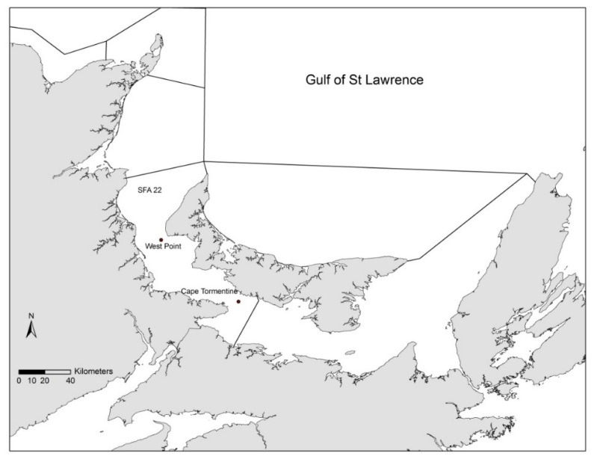
Figure 1. Study area of the scallop drag selectivity experiment on the West Point and Cape Tormentine beds in SFA 22.
DREDGE SELECTIVITY STUDY - CAPE TORMENTINE BED
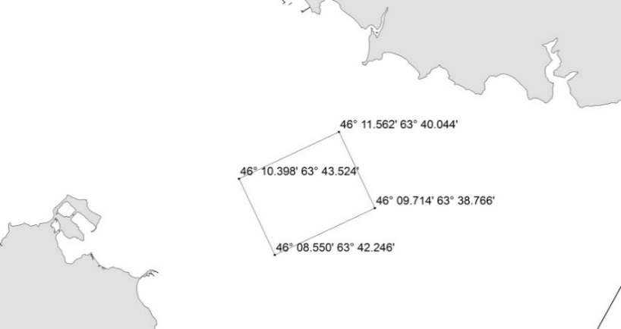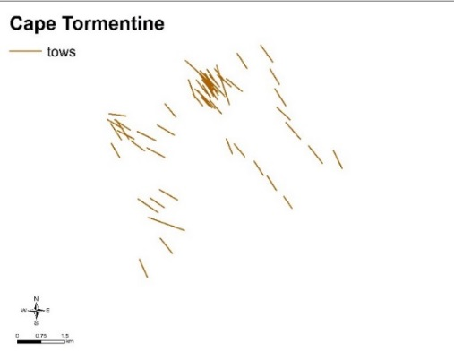
DRAG SELECTIVITY STUDY – WEST POINT BED
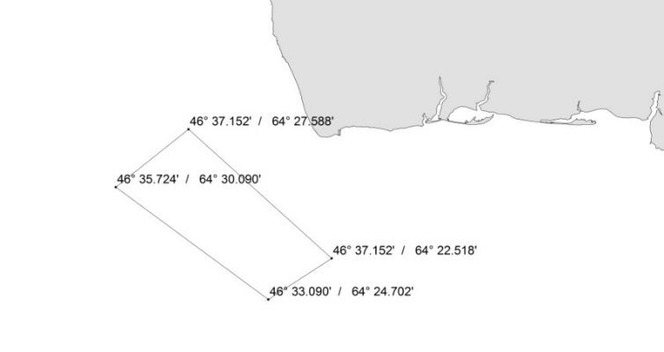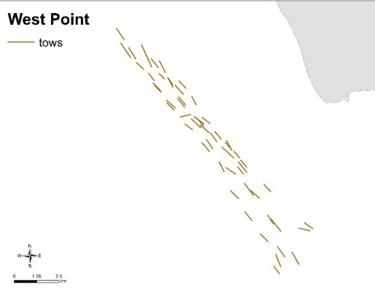

Table. Description of commercial fishing vessels used during the selectivity study on the Cape Tormentine and West Point scallop beds in SFA 22 in May 2018.
Vessel Name | Honker Stomper 1 | Damien
Site (Bed) | Cape Tormentine | West Point
Captain | Todd O’Hanley | Ricky Gallant
Date | May 1– 3 2018 | May 2– 4 2018
Drag width (ft) | 4.88 m (16’) | 4.88 m (16’)
Number of buckets | 10 | 12*
Bucket width (inches) | 0.46 m (18``) | 0.41 m (16``)
Bucket depth (inches) | 0.30 m (12``) | 0.25 m (10``)
Tows | 54 | 54
Number of scallops measured | 12980 | 4109
*Two outside buckets not included in analysis.
Table. Meat weight corresponding to shell height from study beds (Cape Tormentine and West Point) in SFA 22, derived from meat weight versus shell height regression relationships from this study in May 2018 (see Annex). Based on the meat weight to shell height relationship, the average the meat weight of an 89 mm (3½”) scallop is 20% to 24% heavier than an 83 mm (3¼”) scallop.
Bed | Ring Size  (inches) | Shell Height (mm) | Meat Weight  (g) | Increase in Meat Weight
Cape Tormentine
 | 3¼ | 82.6 | 12.2
 | 3½ | 88.9 | 14.6 | 20%
 | 4 | 101.6 | 20.1 | 38%
West Point
 | 3¼ | 82.6 | 11.2
 | 3½ | 88.9 | 13.9 | 24%
 | 4 | 101.6 | 20.6 | 48%

Table. Average meat weight of scallops greater than 88.9 mm in the catch and corresponding meat count for each ring size studied for each bed (Cape Tormentine and West Point) in SFA 22 during the May 2018 selectivity study.
Bed | Ring Size  (inches) | Meat Weight  (g) | Meat Count  (per 500g)
Cape Tormentine
 | 3¼ | 15.6 | 32
 | 3½ | 16.0 | 31
West Point
 | 3¼ | 16.2 | 31
 | 3½ | 19.4 | 26

CAPE TORMENTINE
Size
Descriptive statistics of sea scallop shell heights from the Cape Tormentine bed selectivity study for different bucket types. (R = rubber, S= steel, L= lined)
Shell height statistics (mm) | all | ring size mm | washer type | ring size mm | washer type | ring size mm | washer type | ring size mm | washer type | ring size mm | washer type
 |  | 82.6 | R | 82.6 | S | 88.9 | R | 88.9 | S | L | L
avg | 84.2 | 86.4 |  | 86.6 |  | 86.5 |  | 87.9 |  | 77.2
stds | 13.8 | 9.5 |  | 10.2 |  | 11.5 |  | 10.3 |  | 19.0
max | 117.8 | 114.62 |  | 117.81 |  | 116.0 |  | 112.7 |  | 111.7
min | 14.1 | 16.74 |  | 14.81 |  | 14.1 |  | 37.4 |  | 15.0
n | 13208 | 3331 |  | 3143 |  | 1983 |  | 1311 |  | 3440

Table 3. Mean (±SD, standard deviation) number of scallop per bucket per tow according to ring size and washer type during the selectivity study on the Cape Tormentine bed in May 2018.
Bed  Cape Tormentine | Ring Size* | (inches)  (mm) |  | 3¼  82.6 |  |  | 3½  88.9
 | Washer Type |  | Rubber |  |  | Steel |  |  | Rubber |  | Steel
Number per tow
Small scallops | Mean |  | 12.2 |  | 12.1 |  |  | 7.96 |  | 5.94
 | SD |  | (±5.25) |  | (±5.59) |  |  | (±4.37) |  | (±3.3)
Large scallops | Mean |  | 15.9 |  | 14.9 |  |  | 8.52 |  | 5.17
 | SD |  | (±9.07) |  | (±8.39) |  |  | (±7.49) |  | (±3.45)
All sizes | Mean |  | 28.2 |  | 27.1 |  |  | 16.5 |  | 11.1
 | SD |  | (±12.0) |  | (±12.1) |  |  | (±10.7) |  | (±5.63)
Percent change in small scallops caught with 3½” versus 3¼” rings |  |  |  |  |  |  |  | -35% |  | -51%

Table. Mean catch (meat, g), meat weight (g) and of scallop and number of lobsters per bucket per tow according to ring size and washer type during the selectivity study on the Cape Tormentine bed in May 2018.
Bed  Cape Tormentine | Ring Size* | (inches)  (mm) |  | 3¼  82.6 |  |  | 3½  88.9
 | Washer Type |  | Rubber |  |  | Steel |  |  | Rubber |  | Steel
Catch (meat g) | Mean |  | 191 |  | 191 |  |  | 127 |  | 95.4
>88.9 mm | SD |  | ±82.3 |  | ±88.3 |  |  | ±70.8 |  | ±53.4
Percent change |  |  |  |  |  |  |  | -34% |  | -50%
Average Meat Weight | Mean |  | 15.6 |  | 15.7 |  |  | 16.0 |  | 16.1
(>88.9mm) | SD |  | ±0.59 |  | ±0.57 |  |  | ±0.78 |  | ±1.08
Percent change |  |  |  |  |  |  |  | 2.6% |  | 2.7%
Lobster per tow | Mean  SD |  | 0.157  ±0.391 |  | 0.0556  ±0.268 |  |  | 0.185  ±0.436 |  | 0.0741  ±0.297
Percent change in lobster caught with steel versus rubber washers |  |  |  |  | -65% |  |  |  |  | -60%
*Note that lined buckets (14 mm) caught a total of 27 lobsters (all tows, all days).

Figure . Number of small scallops (<88.9mm) (left) and catch in scallop meat weight (g) in relation to drag ring size (82.6 and 88.9 mm) and washer type (R= rubber; S=steel) on the Cape Tormentine bed in May 2018.

Anova results comparing number of small scallops (<88.9 mm) per bucket per tow between two ring sizes (82.6 mm and 88.9 mm) and two washer types (rubber and steel) on the Cape Tormentine bed in May 2018.

 | Df | Sum Sq | Mean Sq | F value | Pr(>F)
ring_size_mm | 1 | 2972 | 2971.5 | 230.167 | < 2e-16 | ***
washer_type | 1 | 121 | 121.4 | 9.403 | 0.00232 | **
tow | 53 | 4753 | 89.7 | 6.946 | < 2e-16 | ***
Residuals | 376 | 4854 | 12.9

Anova results comparing catch (meat weight in grams of scallops >88.9 mm) per bucket per tow between two ring sizes (82.6 mm and 88.9 mm) and two washer types (rubber and steel) on the Cape Tormentine bed in May 2018.
 | Df | Sum Sq | Mean Sq | F value | Pr(>F)
ring_size_mm | 1 | 680728 | 680728 | 215.515 | < 2e-16 | ***
washer_type | 1 | 26948 | 26948 | 8.532 | 0.0037 | **
tow | 53 | 1202728 | 22693 | 7.184 | < 2e-16 | ***
bucket_position | 5 | 54620 | 10924 | 3.458 | 0.00456 | **
Residuals | 371 | 1171845 | 3159

Anova results comparing number American lobster per bucket per tow between two ring sizes (82.6 mm and 88.9 mm) and two washer types (rubber and steel) on the Cape Tormentine bed in May 2018. Significant diff between washer type, Reduction of 0.1 lobster per bucket per tow with steel washers compared to rubber)
 | Df | Sum Sq | Mean Sq | F-value | Pr(>F)
ring_size_mm | 1 | 0.06 | 0.0579 | 0.461 | 0.4973
washer_type | 1 | 1.22 | 1.2245 | 9.764 | 0.0019**
tow | 1 | 0.02 | 0.0178 | 0.142 | 0.7066
Residuals | 428 | 53.68 | 0.1254

WEST POINT
Size
Table . Descriptive statistics of sea scallop shell heights from the West Point bed selectivity study for different bucket types. (R = rubber, S= steel, L= lined)
Shell height statistics (mm) | all | ring size mm | washer type | ring size mm | washer type | ring size mm | washer type | ring size mm | washer type | ring size mm | washer type
 |  | 82.6 | R | 82.6 | S | 88.9 | R | 88.9 | S | L | L
avg | 87.1 | 88.9 |  | 91.8 |  | 93.5 |  | 95.7 |  | 74.0
stds | 18.9 | 14.0 |  | 11.8 |  | 12.1 |  | 12.9 |  | 25.4
max | 131.3 | 117.9 |  | 120.1 |  | 120.2 |  | 131.3 |  | 123.7
min | 11.1 | 24.8 |  | 11.1 |  | 22.3 |  | 11.6 |  | 16.3
n | 4176 | 1099 |  | 838 |  | 658 |  | 490 |  | 1091

Table. Mean number of scallop per bucket per tow according to ring size and washer type during the selectivity study on the West Point bed in May 2018.
Bed  West Point | Ring Size* | (inches)  (mm) |  | 3¼  82.6 |  |  | 3½  88.9
 | Washer Type |  | Rubber |  |  | Steel |  |  | Rubber |  | Steel
Number per tow
Small scallops | Mean |  | 3.62 |  | 1.99 |  |  | 1.37 |  | 0.759
 | SD |  | ±3.54 |  | ±2.27 |  |  | ±1.71 |  | ±1.08
Large scallops | Mean |  | 5.42 |  | 4.84 |  |  | 3.97 |  | 3.19
 | SD |  | ±3.08 |  | ±3.28 |  |  | ±3.23 |  | ±2.64
All sizes | Mean |  | 9.04 |  | 6.83 |  |  | 5.34 |  | 3.94
 | SD |  | ±5.33 |  | ±4.65 |  |  | ±4.31 |  | ±3.23
Percent change in small scallops caught with 3½” versus 3¼” rings |  |  |  |  |  |  |  | 62% |  | 62%

Table. Mean catch (meat, g), meat weight (g) and of scallop and number of lobsters per bucket per tow according to ring size and washer type during the selectivity study on the West Point bed in May 2018.

Bed  West Point | Ring Size* | (inches)  (mm) |  | 3¼  82.6 |  |  | 3½  88.9
 | Washer Type |  | Rubber |  |  | Steel |  |  | Rubber |  | Steel
Catch (meat g) | Mean |  | 97 |  | 86 |  |  | 74.3 |  | 62.1
>88.9 mm | SD |  | ±54.9 |  | ±57.6 |  |  | ±60.5 |  | ±49.8
Percent change |  |  |  |  |  |  |  | -23% |  | -28%
Average Meat Weight | Mean |  | 18 |  | 17.9 |  |  | 18.8 |  | 19.9
(>88.9mm) | SD |  | ±1.94 |  | ±1.75 |  |  | ±2.25 |  | ±2.74
Percent change |  |  |  |  |  |  |  | 4% |  | 11%
Lobster per tow | Mean  SD |  | 0.0463  0.286 |  | 0.0185  0.135 |  |  | 0.037  0.303 |  | 0.037  0.190
Percent change  (steel versus rubber washers) |  |  |  |  | -60% |  |  |  |  | 0%

Figure . Number of small scallops (<88.9mm) (left) and catch in scallop meat weight (g) in relation to drag ring size (82.6 and 88.9 mm) and washer type (R= rubber; S=steel) on the West Point bed in May 2018.

Anova results comparing number of small scallops (<88.9 mm) per bucket per tow between two ring sizes (82.6 mm and 88.9 mm) and two washer types (rubber and steel) on the West Point bed in May 2018.
 | Df | Sum Sq | Mean Sq | F value | Pr(>F)
ring_size_mm | 1 | 327.3 | 327.3 | 99.4 | < 2e-16 | ***
washer_type | 1 | 135.6 | 135.6 | 41.176 | 4.19E-10 | ***
tow | 53 | 1117.4 | 21.1 | 6.404 | < 2e-16 | ***
Residuals | 376 | 1237.9 | 3.3

Anova results comparing catch (meat weight in grams of scallops >88.9 mm) per bucket per tow between two ring sizes (82.6 mm and 88.9 mm) and two washer types (rubber and steel) on the West Point bed in May 2018.
 | Df | Sum Sq | Mean Sq | F value | Pr(>F)
ring_size_mm | 1 | 58448 | 58448 | 31.272 | 4.36E-08 | ***
washer_type | 1 | 14490 | 14490 | 7.753 | 0.00564 | **
tow | 53 | 615747 | 11618 | 6.216 | < 2e-16 | ***
bucket_position | 5 | 24959 | 4992 | 2.671 | 0.02182 | *
Residuals | 371 | 693407 | 1869

Anova results comparing number American lobster per bucket per tow between two ring sizes (82.6 mm and 88.9 mm) and two washer types (rubber and steel) on the West Point bed in May 2018. Reduction of 0.1 lobster per bucket per tow with steel washers compared to rubber)
No sign diff between ring size and washer type on lobster caught. Sign differences in number of lobster caught between tows (F=1.645, p=0.005).
 | Df | Sum Sq | Mean Sq | F | value | Pr(>F)
ring_size_mm | 1 | 0.002 | 0.00231 |  | 0.044 | 0.83426
washer_type | 1 | 0.021 | 0.02083 |  | 0.395 | 0.53028
tow | 53 | 4.604 | 0.08687 |  | 1.645 | 0.00466 | **
Residuals | 376 | 19.852 | 0.0528

Removed from analysis because of missing data or flipped bucket:
Site | Bucket number | Ring size | Tow number
Cape Tormentine | 1 | 82.6 | 13
 | 3 | 82.6 | 13
 | 6 | 14 | 16
 | 6 | 14 | 18
 | 6 | 14 | 60
 | 7 | 88.9 | 47
 | 9 | 88.9 | 56
West Point | 4 | 14 | 19
 | 4 | 14 | 35
 | 4 | 14 | 40
 | 4 | 14 | 55
 | 4 | 14 | 57
 | 9 | 14 | 20

Annex 1.
Steel washers (rings linked with all steel washers)
Rubber and steel (rings linked vertically by one steel washer and one rubber washer)
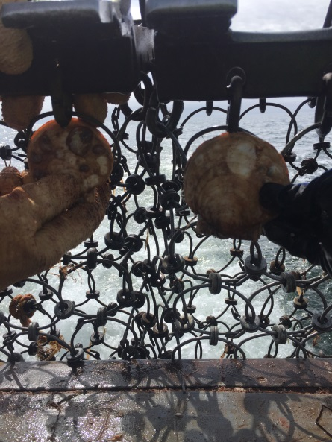
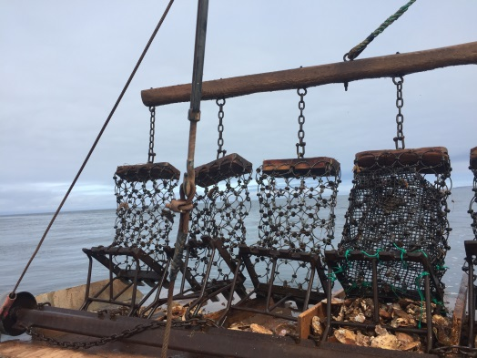
Liner made with 14mm mesh vexar netting

10 BUCKET DRAG

3½’’
S
3½’’
R
3½’’
S

3¼’’
S
3¼’’
L

3½’’
R
3¼’’
R
3¼’’
L
3¼’’
S
3¼’’
R

S= steel rings only
R= rubber washers on the vertical
L= liner of 14mm vexar
Note: for the 12 bucket drag configuration used on the West Point bed, two outside buckets were constructed with steel washers and were not included in analysis.

Annex.
Shell height to meat weight relationship for selectivity study (May 2018) on the Cape Tormentine bed and West Point bed (using R)
Natural log transformation
library("FSA", lib.loc="~/R/win-library/3.4")
> library("car", lib.loc="~/R/win-library/3.4")
> library("magrittr", lib.loc="~/R/win-library/3.4")
> library("dplyr", lib.loc="~/R/win-library/3.4")
> library("plotrix", lib.loc="~/R/win-library/3.4")
> library("Matching", lib.loc="~/R/win-library/3.4")
> library("ggplot2", lib.loc="~/R/win-library/3.4")
>
>
>
> data<-read.csv("C:/Users/NilesMM/Desktop/selectivity study/scallop selectivity study 2018 lab data.csv",
+ stringsAsFactors = F)%>%
+
+ ##Add new variable logW, logL and cf (Condition Factor)
+ mutate(logW=log(muscle_weight_g), logL=log(shell_height_mm))%>%
+ mutate(cf=muscle_weight_g/(shell_height_mm*.01)^3)

> fit1<-lm(logW~logL,data=capedata)
> coef(fit1)
(Intercept) logL
-8.003983 2.367109
> Anova(fit1)
Anova Table (Type II tests)

Response: logW
Sum Sq Df F value Pr(>F)
logL 4.4211 1 183.84 < 2.2e-16 ***
Residuals 2.1162 88
---
Signif. codes: 0 ‘***’ 0.001 ‘**’ 0.01 ‘*’ 0.05 ‘.’ 0.1 ‘ ’ 1
> summary (fit1)

Call:
lm(formula = logW ~ logL, data = capedata)

Residuals:
Min 1Q Median 3Q Max
-0.52190 -0.07656 0.01205 0.10775 0.32269

Coefficients:
Estimate Std. Error t value Pr(>|t|)
(Intercept) -8.0040 0.7962 -10.05 2.81e-16 ***
logL 2.3671 0.1746 13.56 < 2e-16 ***
---
Signif. codes: 0 ‘***’ 0.001 ‘**’ 0.01 ‘*’ 0.05 ‘.’ 0.1 ‘ ’ 1

Residual standard error: 0.1551 on 88 degrees of freedom
Multiple R-squared: 0.6763, Adjusted R-squared: 0.6726
F-statistic: 183.8 on 1 and 88 DF, p-value: < 2.2e-16
> (cf<-logbtcf(fit1,10)) #correction factor
[1] 1.065825
> cf*(exp(plogW)) #back transformation with bias correction
1 2 3
11.38734 15.04893 19.31162
>
>
> ##confidence interval of the mean
>
> mlogW<-predict(fit1,nd,interval="confidence")
> cf*(exp(mlogW))
fit lwr upr
1 11.38734 10.62047 12.20957
2 15.04893 14.47931 15.64096
3 19.31162 18.62704 20.02135
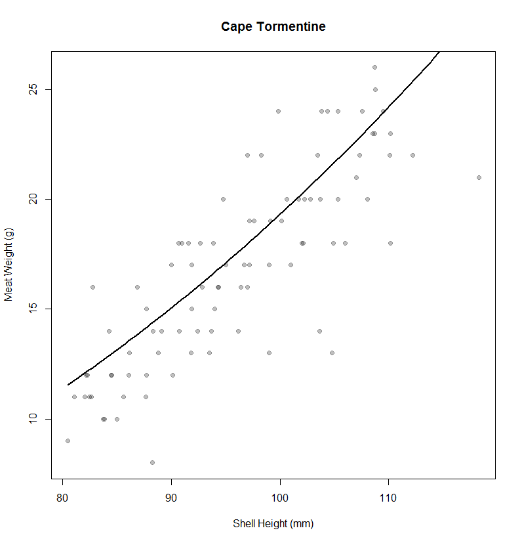
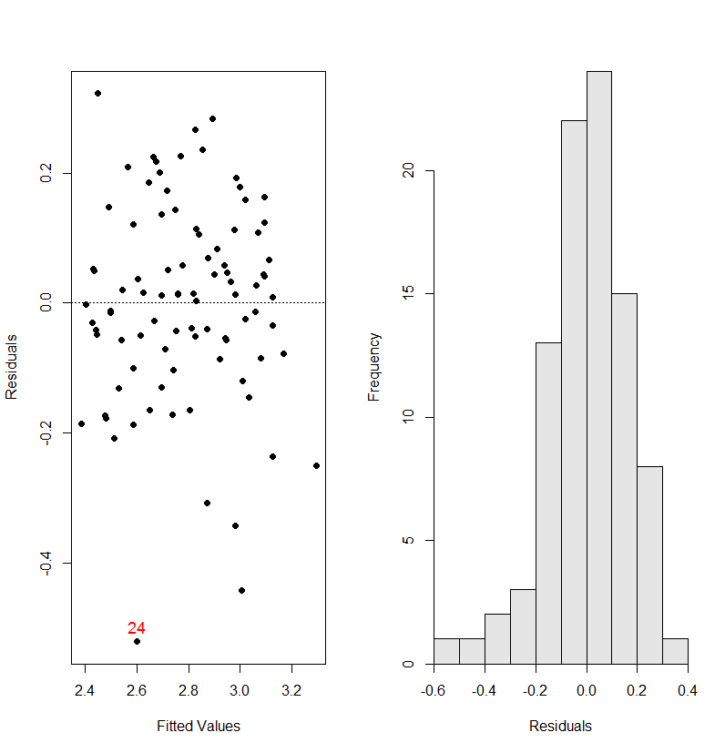
> ##west point bed year 2018
> westdata<-filterD(data,Site=="West Point")
> fit1<-lm(logW~logL,data=westdata)
> coef(fit1)
(Intercept) logL
-10.614699 2.944628
> Anova(fit1)
Anova Table (Type II tests)

Response: logW
Sum Sq Df F value Pr(>F)
logL 13.7602 1 1059.5 < 2.2e-16 ***
Residuals 1.6883 130
---
Signif. codes: 0 ‘***’ 0.001 ‘**’ 0.01 ‘*’ 0.05 ‘.’ 0.1 ‘ ’ 1
> summary (fit1)

Call:
lm(formula = logW ~ logL, data = westdata)

Residuals:
Min 1Q Median 3Q Max
-0.31998 -0.07299 -0.00209 0.06032 0.29386

Coefficients:
Estimate Std. Error t value Pr(>|t|)
(Intercept) -10.61470 0.41467 -25.60 <2e-16 ***
logL 2.94463 0.09046 32.55 <2e-16 ***
---
Signif. codes: 0 ‘***’ 0.001 ‘**’ 0.01 ‘*’ 0.05 ‘.’ 0.1 ‘ ’ 1

Residual standard error: 0.114 on 130 degrees of freedom
Multiple R-squared: 0.8907, Adjusted R-squared: 0.8899
F-statistic: 1060 on 1 and 130 DF, p-value: < 2.2e-16
> cf*(exp(plogW)) #back transformation with bias correction
1 2 3
10.21 14.44 19.69
> mlogW<-predict(fit1,nd,interval="confidence")
> cf*(exp(mlogW))
fit lwr upr
1 10.21 9.799 10.63
2 14.44 14.089 14.80
3 19.69 19.302 20.09

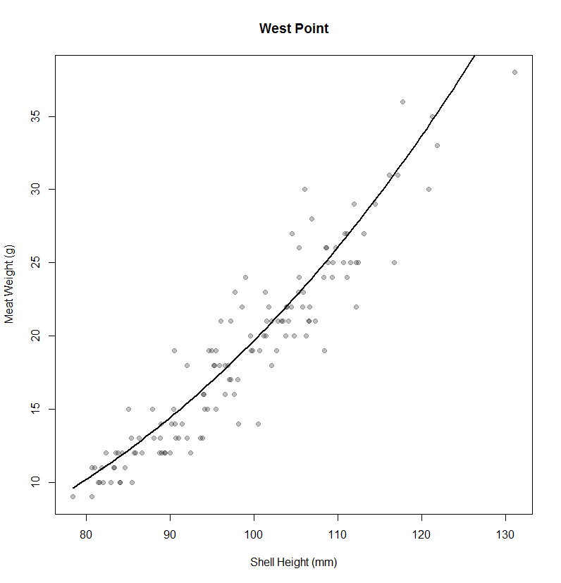
Regression of shell height on meat weight in SYSTAT lnx vs lny from 2001-2005 at-sea sampling data.

CAPE TORMENTINE
Dependent Variable ¦ LOGMW_G
N ¦ 1,582
Multiple R ¦ 0.86
Squared Multiple R ¦ 0.74
Adjusted Squared Multiple R ¦ 0.74
Standard Error of Estimate ¦ 0.19

Regression Coefficients B = (X'X)⁻¹X'Y

¦ Std.
Effect ¦ Coefficient Standard Error Coefficient Tolerance t p-Value
---------+--------------------------------------------------------------------------
CONSTANT ¦ -10.86 0.20 0.00 . -54.72 0.00
LOGSH_MM ¦ 2.95 0.04 0.86 1.00 66.81 0.00

Confidence Interval for Regression Coefficients

¦ 95.0% Confidence Interval
Effect ¦ Coefficient Lower Upper VIF
---------+-------------------------------------------------
CONSTANT ¦ -10.86 -11.25 -10.48 .
LOGSH_MM ¦ 2.95 2.86 3.04 1.00

Analysis of Variance

Source ¦ SS df Mean Squares F-Ratio p-Value
-----------+---------------------------------------------------
Regression ¦ 154.12 1 154.12 4,463.86 0.00
Residual ¦ 54.55 1,580 0.03

WEST POINT
Dependent Variable ¦ LOGMW_G
N ¦ 1,250
Multiple R ¦ 0.79
Squared Multiple R ¦ 0.62
Adjusted Squared Multiple R ¦ 0.62
Standard Error of Estimate ¦ 0.24

Regression Coefficients B = (X'X)⁻¹X'Y

¦ Std.
Effect ¦ Coefficient Standard Error Coefficient Tolerance t p-Value
---------+--------------------------------------------------------------------------
CONSTANT ¦ -10.37 0.29 0.00 . -36.25 0.00
LOGSH_MM ¦ 2.86 0.06 0.79 1.00 45.47 0.00

Confidence Interval for Regression Coefficients

¦ 95.0% Confidence Interval
Effect ¦ Coefficient Lower Upper VIF
---------+-------------------------------------------------
CONSTANT ¦ -10.37 -10.93 -9.81 .
LOGSH_MM ¦ 2.86 2.74 2.99 1.00

Analysis of Variance

Source ¦ SS df Mean Squares F-Ratio p-Value
-----------+---------------------------------------------------
Regression ¦ 121.47 1 121.47 2,067.51 0.00
Residual ¦ 73.32 1,248 0.06

